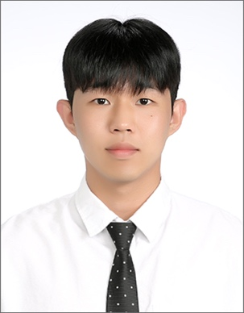

박민영, MinYoung Park
alsdud0229@koreatech.ac.kr ⎪ (+82) 10.2362.4996

SUMMARY
Undergraduate student with a growing interest in Organizational Behavior and Human Resource Management, focusing on employee motivation, organizational culture, and social network dynamics within firms. Seeking to pursue advanced studies in HR/OB and develop research capabilities that contribute to evidence-based people management and organizational effectiveness.

WORKS IN PROGRESS
Park, M., Kim, M., & Kim, T. The impact of social networks on creative behavior among science and technology professionals: The moderating role of work–life balance and the mediating role of knowledge sharing.

PRESENTATIONS
Park, M., Kim, M., & Kim, T. The impact of social networks on creative behavior among science and technology professionals: The moderating role of work–life balance and the mediating role of knowledge sharing. Paper presented at the 2025 Korean Association of Human Resource Development (KAHRD), Cheongju, South Korea.

EDUCATION
Korea University of Technology and Education|Convergence Management CHEONAN, Korea | Mar. 2022 – Feb. 2028(expected)

OTHER INFORMATION

Skills: Advanced Data Analytics Semi-Professional (ADsP)

